GDE405 Readings & Assignments: Week 3

Week 3 Reading
Complete the following reading early in the week:
- The online lectures for Week 3.
- The following chapters from the text, Drawing From Life by Clint Brown & Cheryl McLean:
  - Chapter 7: Anatomy of the Limbs
  - Chapter 8: Heads and Portraits
- The following pages from the book, Dynamic Figure Drawing by Burne Hogarth:
  - Chapter 3, pp. 65–104
Week 3 Assignments Overview
Assignment Summary: Week 3 | Due
Assignment 1: Discussion Questions | Tuesday, October 21, 2008
Assignment 2: Drawing from Classical Statuary | Thursday, October 23, 2008
Assignment 3: Drawing with Conté Artists from History | Thursday, October 23, 2008
Assignment 4: Live Drawing Session with Your Model | Saturday, October 25, 2008
Remember that all assignment details can be found on the assignment pages located throughout the week. Go to those specific pages for direction on how to complete each individual assignment.

Week 3 Overview

Learning Outcomes:
- Drawing from classical statuary.
- Drawing with techniques from artists from history.
- Drawing with a range of mixed media.
- How the use of art historical subject matter can broaden the approach to figure drawing.
- To experiment with the tools and techniques used by artists in history such as: conté crayon, pen and ink, and mixed media.

The Figure in Art History
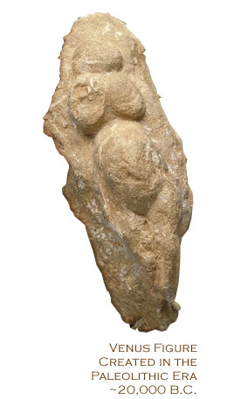
In this week, we will take a look at figure drawings done by historical artists and use the work done in the Classical age to create our own drawings. You will also be experimenting with various media to complete your artwork.
Artists have been using the figure as an art form since the beginning of art making itself. The cave painters drew not only animals, but also themselves and each other. Studying the approaches of artists using the figure throughout history is an important step in the process of developing your own approach to representing the figure. The figure has been used to represent gods and goddesses, in portrayals of the stories and characters in the Bible, as a form of portraiture for the papacy and royalty, in depictions of everyday life, and, more recently, as a form to explore increasingly abstract and conceptual modes.
The most frequently studied figurative artists are the artists from the 5th Century B.C. and the Renaissance. These include Praxiteles, Michelangelo, Leonardo, Raphael, Titian, Durer, and many others. Auguste Rodin and Edgar Degas are Impressionists also frequently studied. However, there are as many approaches to drawing the figure as there are artists. Women artists were traditionally not given access to the nude figure until the late 19th century. However, many used their family and friends as well as themselves as subjects. They include Artemisia Gentileschi, Mary Cassatt, Berthe Morisot, Frida Kahlo, and Kathe Kollwitz. Additionally, many artists from other cultures and parts of the world had their own unique way of representing the figure. Studying western and non-western approaches to the figure can be an illuminating way to discover techniques and materials that may not be familiar to you.
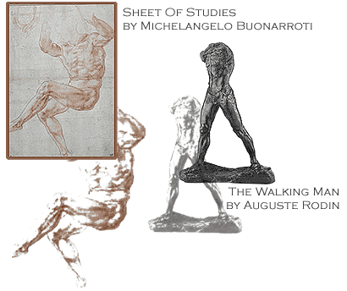
Many of the Renaissance artists studied medical anatomy in order to better understand what was going on underneath the surface of the body. Michelangelo was one of the most famous for finding corpses to study and work from. Study the figures below to understand what makes these works so powerful.

Techniques from History
Breaking the Figure into Smaller Forms
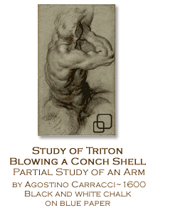
In addition to studying the form from an anatomical perspective, it is also useful to break the body up into different shapes and enlarge the forms in order to understand them better and to relax more in your approach to that particular body part. The old masters would use this approach frequently when sketching a composition to better understand a specific area or to work out a particular problem in the pose.
Variety of Media
Using a variety of materials can also help expand your approach to the figure. Working both with a linear and volume tool (pencil and charcoal/pastel) in addition to using a subtractive tool (eraser) and modeling tools can help create figures that have volume and give a sense of three-dimensionality. The artists from the Renaissance used different types of drawing materials to increase their depiction of the volume of the forms.
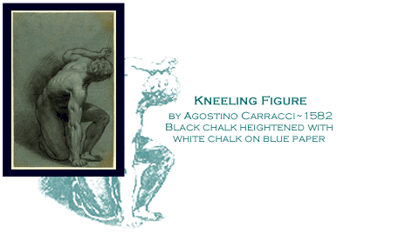
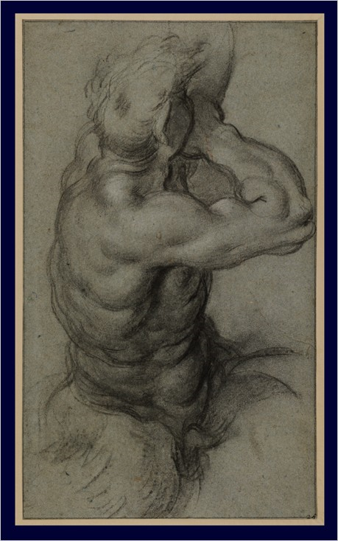

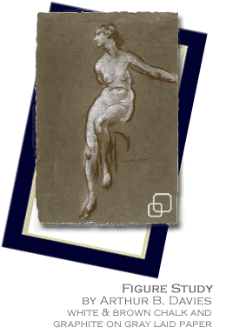
Cropping
Cropping is a very powerful compositional device in dynamic figure drawing. However, where to crop is important to understand. Cropping can either add an exciting, dynamic element to your drawing or make it look completely amateurish. Cropping certain parts of the body out of a drawing should occur at the joints rather than mid-way through a limb or torso to avoid an amputated look. In addition, add some light lines to infer what you are cropping rather than just an abrupt stop.
Blowing Up a Form
Blowing up a form is also an exciting device used by the masters. Michelangelo often concentrated on the torso and would enlarge it to better understand the forms. This also made for some very powerful drawings in and of themselves. However, it can also be used inaccurately and not to the best advantage for the piece. Blowing up a part or section of the body is also the beginning of using the body to abstract the form.
Use of Toned Paper
Toned paper is frequently seen in older drawings. Artists use the tone of the paper as the mid-tone and use darks and lights working off that tone to depict the value.
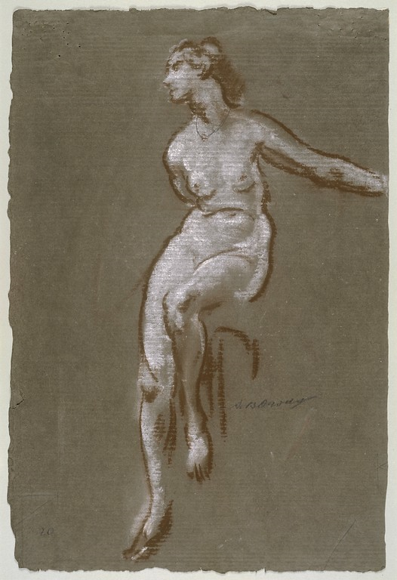

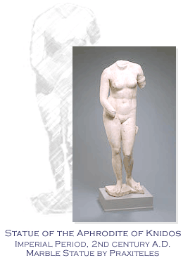
Drawing from Classical Statuary
Artists from the Classical Age in Athens perfected the study of the human form in space. The most noted 5th century sculptor was Praxiteles, who modeled many of the figures on the Parthenon and other temples built during that period. Many artists learned the techniques of carving out of marble and the classical period was born. The 4th and 5th century Athenian sculptors perfected the balance, anatomy, and nuances of the sculptured human form. The sculptures from this period were copied extensively during the Roman period and are breathtaking works from which to draw and learn about a dynamically portrayed figure.

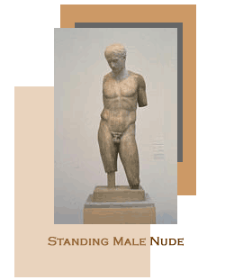
Working from Classical Statuary in Local Museums
It is always optimal to do as much of your work from life as possible, relying on photographs only for secondary purposes. Working from statues is a time-honored tradition in the study of figurative art. Consider visiting your local museum with a sketchpad and materials in hand and sketch the sculptures, masks, and other three dimensional works from such countries as Egypt, Greece, Asia, and Africa. By sketching these forms of life, you will have a better understanding of how they exist in space.

Modeling the Figure in Clay
To partake in the centuries-old tradition of modeling the figure in sculpture can be easier than you think. Purchase some self-hardening clay from your local art supply store and sculpt a torso or parts of the body in clay. By having to deal with the figure in a three-dimensional manner you will be forced to resolve issues of balance and proportion, as well as learn another way to represent the form in space. You can also use your piece to draw from.

Drawing with Artists from History
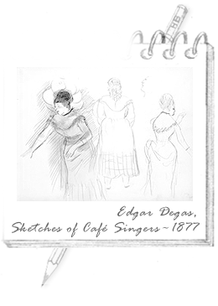
Learning to really see how artists depict the figure will greatly improve your own figure drawing. In addition to studying the thumbnails here, take a visit to your local library and check out several books with master's drawings. Study and copy as many drawings as you can, imitating the composition and media the artists originally used. Look up additional drawings from the following artists and consider the following observations as well as making some of your own.

Degas
Edgar Degas sketched women dancing during their rehearsals and in performances. A master of capturing the essence of a moment, his relaxed yet efficient use of line indicates his confidence in his subject. He also places the figures as if they have moved sequentially.
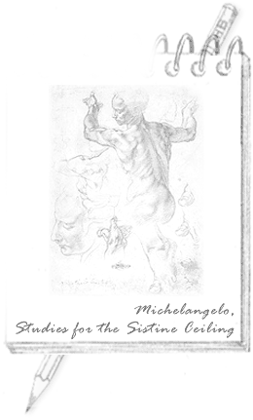

Michelangelo
When looking at Michelangelo's drawings, note the subtleties in the depiction of light and dark. Consider how many tones in a value scale he achieved with just one drawing tool. Note the marks he makes, which range from quick scribbles to precise modeling. The weight of his line changes to indicate where light is hitting the form. The figure appears to leap off the page. His sculptural approach to the body is evident in the precise modeling that is the hallmark of his figure drawings.

Raphael
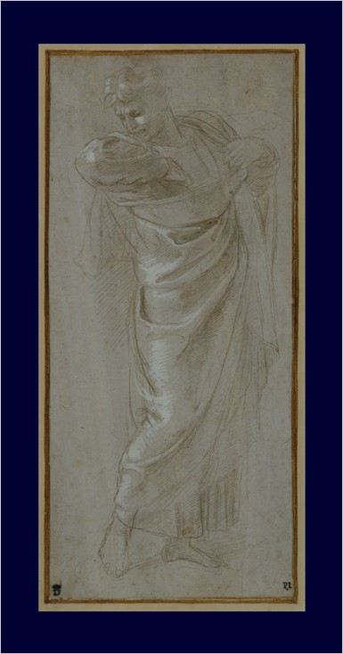
Raphael is an artist to study for grace and delicacy of line, particularly in the drawing you see to the left. There is a softness to the drapery and a sweetness to the features. However, the figure is powerfully represented both in anatomy and proportion. He has drawn the figure on toned paper that adds to the ethereal quality of the work. The contra-posto pose is evident in the diagonals of the head, shoulders, and pelvis.

Rembrandt
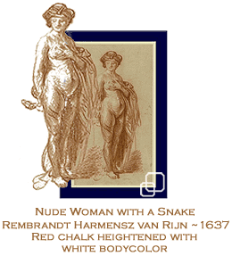
Rembrandt is an interesting artist to study due to the differences between his drawings and his paintings. An artist's drawings are often much more relaxed and simpler than his paintings, which are usually labored over for days or weeks on end. Rembrandt used line and tone very efficiently and economically. He also worked frequently in pen and ink, which offer a nice way to depict line and wash together.
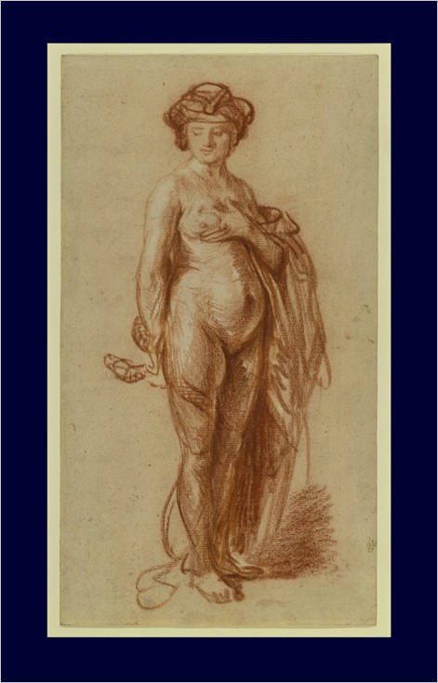

Rubens
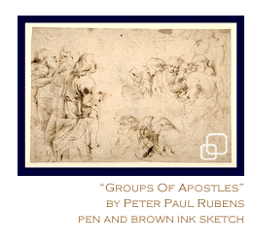
Rubens was an artist who used a range of media from conté to charcoal to pen and ink in his drawings. His compositions are an excellent example of cropping and the use of diagonals to enliven a composition. In addition, his figures are weightier than what we are used to seeing today, evidence of the changing tide in what is considered pleasing in the depiction of the male and female nude forms.
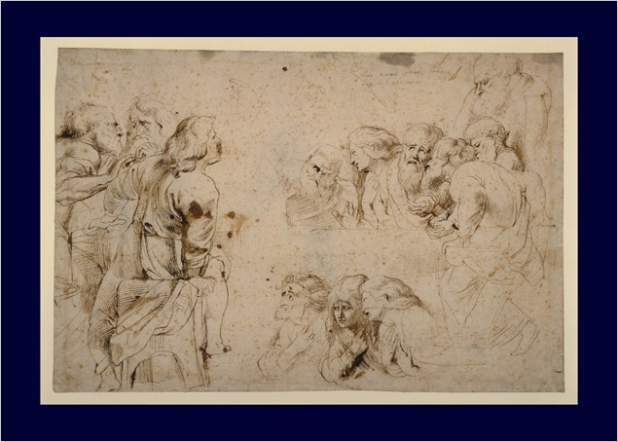

Experimenting with Media
Using your articulated model, we're now going to concentrate on helping you develop more of your own personal style and approach to the figure. The use of the model can be helpful since it will allow you more freedom and you should feel less self-conscious, which will enable you to experiment with your approaches and media. Sometimes the use of a model can be intimidating when trying to experiment. Therefore, use the articulated model to help you relax in your approach.
Try the following approaches:
- Position the model in as many poses as you can, including seated, standing, and reclining poses.
- Set up a simple still life to place the model in context.
- Crop the model.
- Blow up a particular interesting form/shape.
- Add several versions of the model on the same page.

Set yourself up with as many types of drawing media as you have access to. Pen and ink, pastels, conté crayon, toned paper, markers, pencils, charcoal, and erasers are all basic tools from which to start. Put on some music and start to draw.
Begin drawing using the following steps:
Step 1: Laying in your sketch. The first step is to work out your proportions and composition before getting into experimenting with a particular media. However, try to keep yourself as loose as possible. In addition, do not get too dark too fast in this step as you may have trouble later on as you add additional media.
Graphite and charcoal—remember these tools are to be used separately as they do not mix well together. Therefore, when starting any drawing you should decide which direction you will go in from the start. If you are going to use pen and ink or watercolor, it is best to use a light pencil to sketch in first. If you will be using a heavier media such as pastel or charcoal, light vine charcoal can be used.
Step 2: Lights and Darks—with your choice of media, now block in your big lights and big darks. If you are using a color tool, limit yourself to 3-4 colors at this point.
Step 3: Soften the edges of your piece or add lines/tone in-between the big light/dark areas to soften the areas of transition.
Step 4: Model the piece and consider adding another type of media for additional interest. Consider such combinations as:
- Charcoal and Pastel.
- Pencil/Graphite and Watercolor.
- Pen and Ink and Color Markers.
- Conté Crayon and Charcoal.
- Conté Crayon and Graphite.

Assignment 1: Discussion Questions
By Tuesday, October 21, 2008, respond to the discussion questions assigned to you by the facilitator. Submit your responses to the appropriate topic in this Discussion Area. Start reviewing and responding to your classmates as early in the week as possible. You can ask questions or respond generally to the overall experience. Ensure to be honest, clear, and concise. Always use constructive language, even in criticism, to work towards the goal of positive progress.
Grading Criteria: | Maximum Points
Comments are clear and concise. | 4
Students shows interest in the discussion and participation. | 4
Student uses terminology and relates concepts introduced in course studies throughout discussion contributions. | 4
Student brings additional questions and observations into the discussion. | 4
Total: | 16
For assistance with any problems you may have when completing this assignment—OR—to offer your assistance to classmates, please use the Problems and Solutions Discussion area located through the left side navigation link.
Use question one for your essay and respond to two other student's essays.
- Choose a favorite drawing from the Renaissance and a favorite sculpture from 5th century Athens. Compare and contrast the representations of the form.
- Research the work done by any one of the artists from the 5th Century B.C. and the Renaissance. Try to figure out distinct styles in their artistic work. Share your observations with fellow classmates.
- "For accurate figure drawings it is necessary to study the anatomy in detail." Do you agree or disagree with this statement? Why? State your reasons.

Assignment 2: Drawing from Classical Statuary
Do an online or library search for a classical sculpture and copy it in graphite and charcoal. Along with your drawing, post the image you used as a reference.
Scan or shoot the drawing with a digital camera and save the image as a jpeg file. Submit the file along with a copy of the original that you used as a model by Thursday, October 23, 2008 to this Discussion Area.
Review and critique the work of at least two other students. Post your comments by responding to the appropriate thread. You can ask questions or respond generally to the overall experience. Always be honest, clear, and concise, using constructive language, even in criticism, to work toward the goal of positive progress.
Grading Criteria: | Maximum Points
Accurately copied the composition. | 4
Depicted the anatomy correctly as in the sculpture. | 4
Retained value of the form while maintaining the dynamism of the pose. | 4
Participated in the discussion with concise and clear comments. | 3
Total: | 15
For assistance with any problems you may have when completing this assignment—OR—to offer your assistance to classmates, please use the Problems and Solutions Discussion area located through the left side navigation link.
Be sure you find something interesting and have fun with it. Be sure it fits the "Classical" concept. In this case it means Greek Clasical and Roman copies of Greek Classical from around 350 B.C to the beginning of A.D.

Assignment 3: Drawing with Conté Artists from History
Using your black, rust, or brown conté, along with white conté crayon for highlights on toned paper, copy one of the drawings given in the Drawing with Artists from History lecture. You can also choose to create a drawing that is not in the lecture but that have been done by any of the artist mentioned in the lecture, in that case please post the reference you used with it.
Scan or shoot the drawing with a digital camera and save the image as a jpeg file. Submit the file by Thursday, October 23, 2008, to the this Discussion Area.
Review and critique the work of at least two other students. Post your comments by responding to the appropriate thread. You can ask questions or respond generally to the overall experience. Always be honest, clear, and concise, using constructive language, even in criticism, to work toward the goal of positive progress.
Grading Criteria: | Maximum Points
Accurately copied the composition. | 4
Depicted the anatomy correctly as in the source. | 4
Retained value of the form while maintaining the dynamism of the pose. | 4
Participated in the discussion with concise and clear comments. | 3
Total: | 15
For assistance with any problems you may have when completing this assignment—OR—to offer your assistance to classmates, please use the Problems and Solutions Discussion area located through the left side navigation link.
Remember your copying, so try to make it look exactly like their work. This is not an "interpretive" work.

Assignment 4: Live Drawing Session with Your Model
This is now your time to loosen up and have some fun with figure drawing. Choose a block of time where you won't be disturbed. Lay out your drawing media on your table and set yourself up to work.
Pose your model in several different views and choose a few of the best. This exercise is designed to help you free yourself up using the exercises you've done up until this point. Experiment with different media, different poses, different size and types of paper. But do not think too hard about the forms, shapes, accuracy, and so on. This particular session is more about letting your instincts take over and less about concentration and rigidity.
Timing
Conduct your first life drawing standing pose session. Time yourself and create standing, seated and reclining pose drawings using the 4-Step Process. To do your half-hour warm-up, use the following sequence:
- Draw 5 1-minute poses
- Draw 3 2-minute poses
- Draw 1 3-minute pose
- Draw 3 5-minute poses
After your warm-up, you are ready for longer pose studies:
- Draw 2 15-minute poses
- Draw 1 half-hour pose
- Scan or shoot the drawings with a digital camera and save the image as a jpeg file. Submit samples of your drawings, by Saturday, October 25, 2008, to the this Discussion Area.
- Describe in detail how your live drawings progressed after working from the art history sources as well as experimenting with new media. Post your description, by Saturday, October 25, 2008, to this Discussion Area.
- Review and critique the work of at least two other students by the end of the week. Discuss at least three positive areas and three areas for improvement in the drawing.
Grading Criteria: | Maximum Points
Spontaneity and dynamism of the pose. | 4
Variety and innovation of approaches adopted. | 4
Completeness of drawings. | 4
Attention to the lights, darks, and the weight of lines. | 4
Clear communication of ideas in the discussion. | 4
Participation and constructive feedback. | 4
Total: | 24
For assistance with any problems you may have when completing this assignment—OR—to offer your assistance to classmates, please use the Problems and Solutions Discussion area located through the left side navigation link.
You don't need to submit every drawing but submit some of your quick drawings and certainly your long poses.

